Find the eno ename ,salary whose salary >4000 and job_status =professor

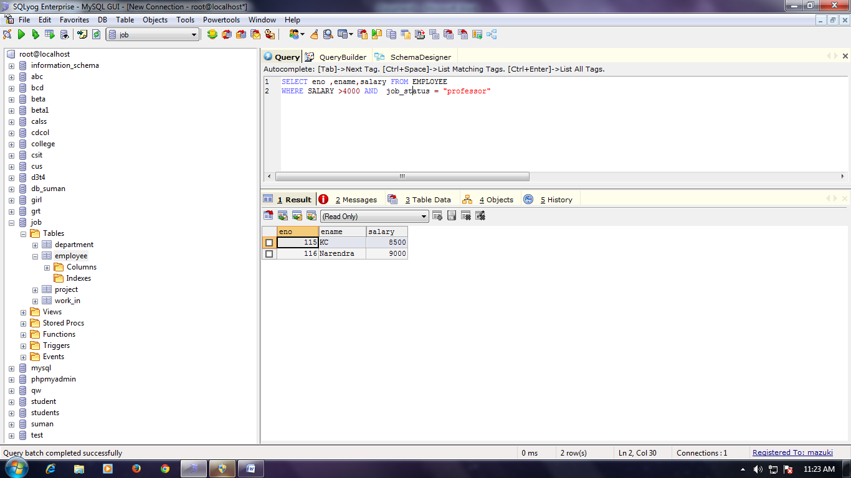

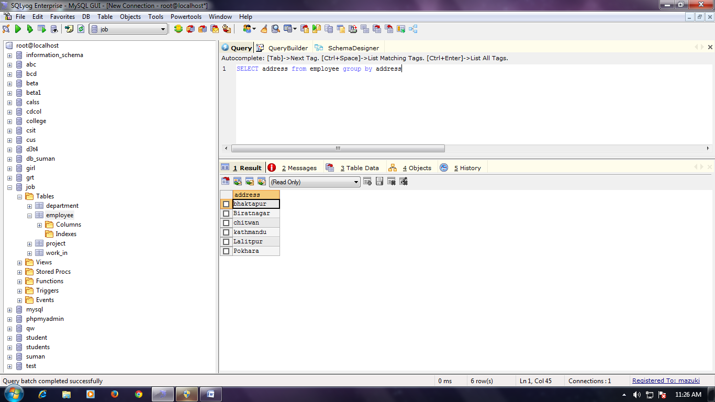

Find the eno ename ,salary whose salary >4000

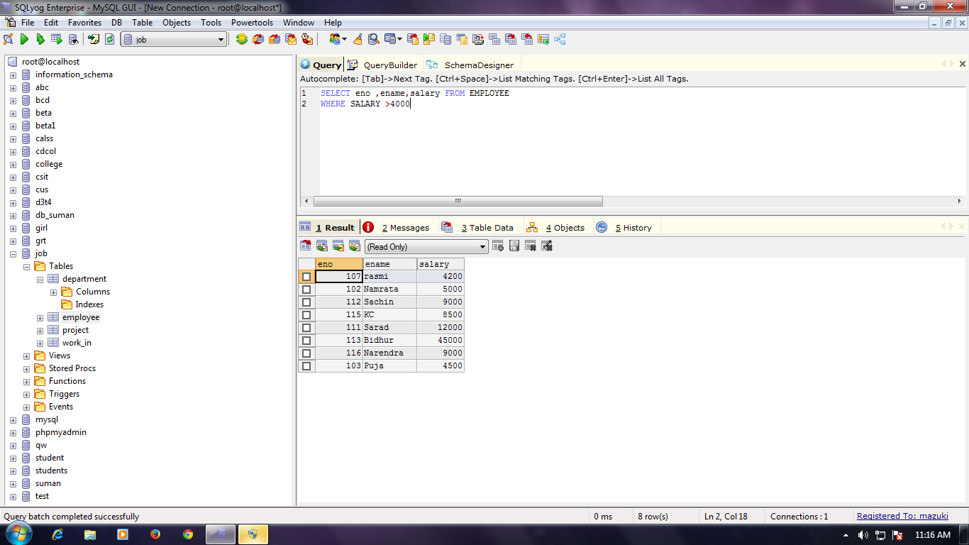

Find the eno ename ,age,salary whose age is between 20 and 28

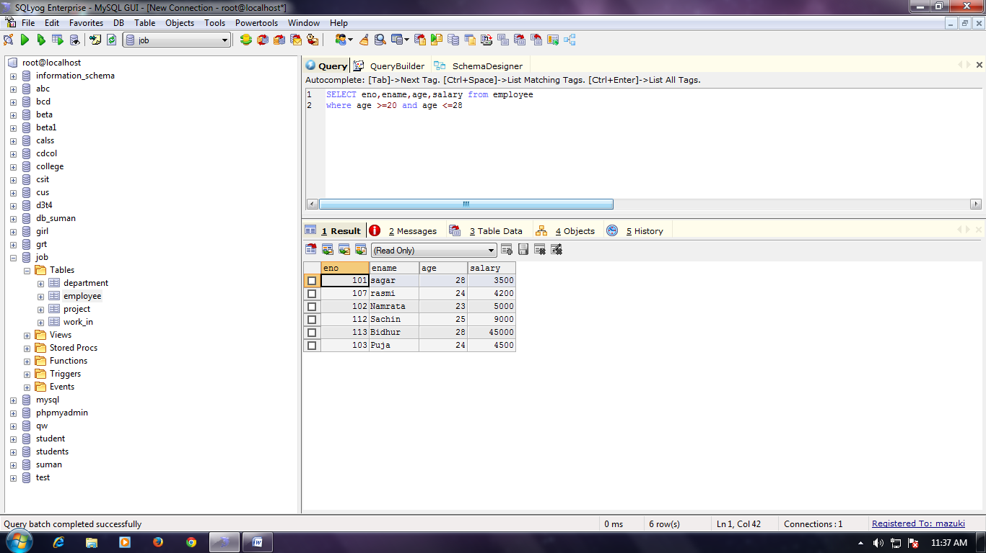

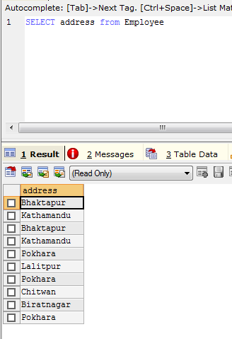

Distinct address

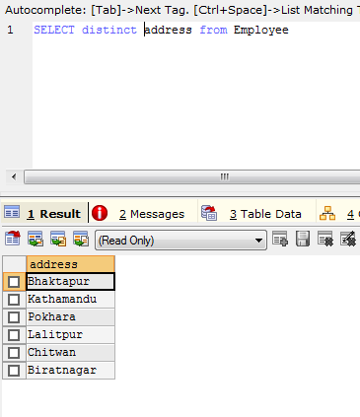

Find the eno, ename, salary of the employee whose department no is 20 or job status is research fellow.

